Chapter 8

Confidence Intervals

8.1 Introduction to Confidence Intervals
In chapters 1, we learned to use the sample mean to estimate the mean of an entire population (as well as using the sample proportion to estimate the true population proportion). However, these point estimates by themselves are of limited use because they do not contain any measure of uncertainty. Remember that a sample mean (or sample proportion) is useless without a measure of spread.
The appropriate measure of spread for both a sample mean and sample proportion was presented in chapter 7. The sampling distribution of the statistic (mean or proportion) was introduced together with the standard deviation of the sample statistic (mean or proportion).
This chapter introduces another type of estimate, an interval estimate. Interval estimates are also (and more commonly) known as confidence intervals. A confidence interval provides more information than does a point estimate; a confidence interval includes both the point estimate and a measure of uncertainty (called the margin of error).
Chapter 8 also includes material on how to select a sample size for a desired margin of error.

8.2 Confidence Intervals: Some Preliminaries
A 90% confidence interval is an interval that “captures” the middle 90% of the sampling distribution of the statistic. Notice that the middle 90% of the distribution is obtained by considering the numbers that are 1.645 standard deviations to the left and to the right of the mean. The number 1.645 is denoted by z_{0.05} since it “cuts off” the upper 5% of any normal distribution.
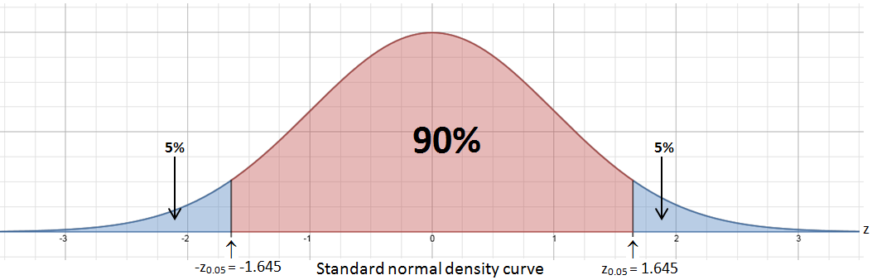
Likewise, a 95% confidence interval captures the middle 95% of the sampling distribution of the statistic. The middle 90% of the distribution is obtained by considering the numbers that are 1.960 standard deviations to the left and to the right of the mean. The number 1.960 is denoted by z_{0.025} since it “cuts off” the upper 2.5% of any normal distribution.
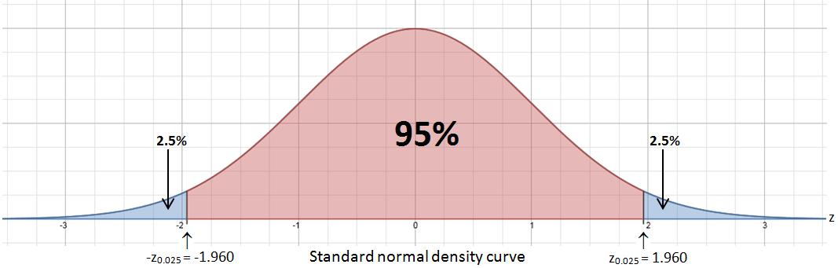
Finally, a 99% confidence interval captures the middle 99% of the sampling distribution of the statistic. The middle 99% of the distribution is obtained by considering the numbers that are 2.576 standard deviations to the left and to the right of the mean. The number 2.576 is denoted by z_{0.005} since it “cuts off” the upper 0.5% of any normal distribution.
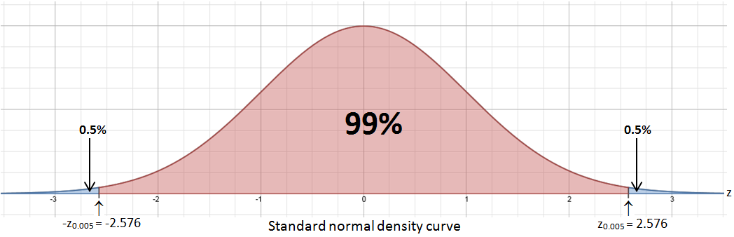

These (and similarly determined) numbers are important in constructing a confidence interval.
8.3 Point Estimates and Interval Estimates
Definition: Point Estimate
A point estimate is a single-valued estimate of a population parameter.
- A sample mean is a point estimate of a population mean μ.
- A sample proportion is a point estimate of a population proportion p.
Example 1: The following are examples of point estimates
- From a random sample of 9 batteries from a production run of 10,000 batteries, the mean lifetime is 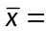950.00 minutes. This is a point estimate for the true mean lifetime of all 10,000 batteries.
- From a random sample of 41 long-haul truck drivers at a trucking company, the mean systolic blood pressure is 130 mm Hg. This is a point estimate for the true mean systolic blood pressure of all long-haul truck drivers at this company.
- From a random sample of 1411 youths from across the state of Pennsylvania, researchers found the 219 youths were obese. The point estimate for the proportion of all PA youths that are obese is 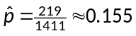 .
Recall the following important results from chapter 7….
- The sample mean is an unbiased estimate of the population mean μ.
- When the sampled population has a normal distribution, the sampling distribution of the sample mean also has a normal distribution with mean 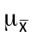 = 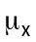and 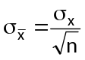as long as the population size is at least ten times the size of the random sample ( N > 10n ).
- When the sampled population does not have a normal distribution, the sampling distribution of the sample mean still has an approximate normal distribution with mean = and 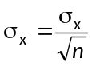as long as the population size is at least ten times the size of the random sample ( N > 10n ) and the sample size is large ( n > 30 ).
- The sample proportion is an unbiased estimate of the population proportion p.
- The sampling distribution of the sample proportion is approximately normal with mean 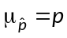and standard deviation 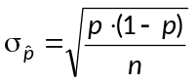as long as the population size is at least ten times the size of the random sample ( N > 10n ) and both n⋅p > 10 and n⋅(1 – p) > 10.

8.3 Point Estimates and Interval Estimates
An interval estimate, more commonly known as a confidence interval is a range of plausible values for a population parameter.
Example 2: The following are examples of interval estimates
- We are 90% confident that the true mean lifetime of all 10,000 batteries in the production run is between 965.5 minutes and 1064.2 minutes.
- We are 95% confident that the true mean systolic blood pressure of all long-haul truckers at a particular company is between 126.2 mm Hg and 133.8 mm Hg.
- We are 99% confident that the true proportion of obese youths in Pennsylvania is between 0.130 and 0.180.
Definition: Confidence Interval and Confidence Level
A C% confidence interval gives an interval of plausible values for a parameter. The interval is calculated from the data and has the form
point estimate ± margin of error.
The difference between the point estimate and the true parameter value will be less than the margin of error in C% of the samples.
The confidence level C gives the overall success rate of the method for calculating the confidence interval. That is, in C% of all possible samples, the method yields an interval that captures the true parameter value.
Interpreting the Confidence Interval
To interpret a C% confidence interval for a unknown parameter, we say “We are C% confident that the [insert parameter in context] is between [insert lower bound of CI] and [insert upper bound of CI].”
Interpreting the Confidence Level
To say that we are C% confident is shorthand for “The method used to produce the interval will contain the true [insert parameter in context] in C% of all possible samples of the same size from this population.”
Inference Procedures
In the pages that follow, we will learn how to construct and interpret a C% confidence interval for four situations.
- A z-CI for a population mean (σ known or assumed)
- A t-CI for a population mean (σ unknown)
- A t-CI for a mean difference (matched pairs design)
- A z-CI for a population proportion
Always begin a confidence interval exercise by stating the correct inference procedure.
8.4 A z-Confidence Interval for a Population Mean: σ known or assumed
The general form for a confidence interval is
Point Estimate ± Margin of Error
Point Estimate ± (Critical Value)⋅(Standard Deviation of the Statistic)
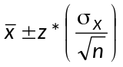
The critical value is the number z-value needed to “capture” the middle C% of the distribution and was first introduced on page 8-2.
When constructing a 90% confidence interval using the z-distribution, use
z* = z_{0.05} = 1.645.
When constructing a 95% confidence interval using the z-distribution, use
z* = z_{0.025} = 1.960.
When constructing a 99% confidence interval using the z-distribution, use
z* = z_{0.005} = 2.576.

When documenting the solution to any inference procedure, use the C-C-C-C method:
- Choose the correct inference procedure.
- Check the conditions for the inference procedure.
- Carry out the inference procedure.
- State your conclusion by interpreting the confidence interval in context.
8.4 A z-Confidence Interval for a Population Mean:  known or assumed
A z-Confidence Interval for a Population Mean: σ known or assumed
When the conditions are met and the population standard deviation is known or assumed, a C% confidence interval for the unknown mean μ is where z* is the critical value for the z-distribution, with C% of the area between –z* and z*. We call the quantity 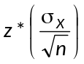 the margin of error.
The conditions for this inference procedure are
- A random sample has been selected from the population.
- The 10% condition: Check that N > 10n.
- The population has an approximate normal distribution (so that Theorem 1 can be used) OR the sample size is large (n > 30 so that the Central Limit Theorem can be used).
Example 3
Refer to our production run of 10,000 batteries. We want to estimate the true mean lifetime of all 10,000 batteries from a sample of size n = 9 obtained using line 101 of the random number table.
Battery # | 1922 | 3950 | 3405 | 7562 | 8713 | 9640 | 9125 | 3142 | 5448
Lifetime (min) | 1017 | 973 | 1102 | 979 | 935 | 1032 | 1036 | 978 | 1082
The sample mean lifetime is 1014.89 min. We will use the population standard deviation of  = 90 minutes to construct a 90% confidence interval for the true mean lifetime of all 10,000 batteries.
Solution
Choose the correct inference procedure.
We will calculate a 90% confidence interval for a population mean with a known value of σ.
Check the conditions
- A simple random sample was selected. ✓
- 10% condition: There are indeed more than 10n = 90 batteries in the population. ✓
- Though the sample size is not large, we do know that the population has an approximate normal distribution. Theorem 1 will apply.
Carry out the inference procedure
For a 90% z-confidence interval, use z* = 1.645.
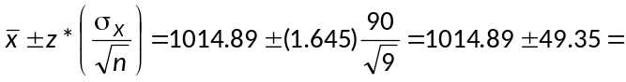(965.5, 1064.2).
State the conclusion by interpreting the confidence interval
We are 90% confident that the true mean lifetime of all 10,000 batteries is between 965.5 minutes and 1064.2 minutes.
8.4 A z-Confidence Interval for a Population Mean: σ known or assumed
Example 4
In the calculation of the confidence interval in example 3, identify the value of each of the following.
- The point estimate of the parameter. _______________
- The critical value. _______________
- The standard deviation of the point estimate. _______________
- The margin of error. _______________
Example 5
In example 3, we interpreted the 90% confidence interval. Now interpret the confidence level of 90%.
Answer
The method used to produce the interval will contain the true mean lifetime of all 10,000 batteries in 90% of all possible samples of size n = 9 from this population.
To illustrate the meaning of a confidence level, here are the confidence intervals based on 20 different simple random samples of size n = 9.
Line # | Point Estimate | Margin of Error | Lower CL | Upper CL
Line 101 | 1014.89 | 49.35 | 965.5 | 1064.2
Line 102 | 992.89 | 49.35 | 943.5 | 1042.2
Line 103 | 1014.67 | 49.35 | 965.3 | 1064.0
Line 104 | 1036.89 | 49.35 | 987.5 | 1086.2
Line 105 | 1015.78 | 49.35 | 966.4 | 1065.1
Line 106 | 953.00 | 49.35 | 903.7 | 1002.4
Line 107 | 1002.22 | 49.35 | 952.9 | 1051.6
Line 108 | 975.78 | 49.35 | 926.4 | 1025.1
Line 109 | 944.11 | 49.35 | 894.8 | 993.5
Line 110 | 1022.44 | 49.35 | 973.1 | 1071.8
Line 111 | 998.44 | 49.35 | 949.1 | 1047.8
Line 112 | 987.56 | 49.35 | 938.2 | 1036.9
Line 113 | 999.00 | 49.35 | 949.7 | 1048.4
Line 114 | 1013.33 | 49.35 | 964.0 | 1062.7
Line 115 | 1040.00 | 49.35 | 990.7 | 1089.4 | ← Hmmmmm!!!!
Line 116 | 1009.78 | 49.35 | 960.4 | 1059.1
Line 117 | 963.67 | 49.35 | 914.3 | 1013.0
Line 118 | 1030.22 | 49.35 | 980.9 | 1079.6
Line 119 | 970.89 | 49.35 | 921.5 | 1020.2
Line 120 | 1020.00 | 49.35 | 970.7 | 1069.4
Examine the 20 confidence intervals.
How many of these confidence intervals contain the true mean lifetime of μ = 990 minutes? _______
What percent of these confidence intervals contain the true mean lifetime of μ = 990 minutes? _____
8.4 A z-Confidence Interval for a Population Mean: σ known or assumed
Interpreting the Confidence Interval: Mark each statement as CORRECT (C) or INCORRECT (I)
___ After taking many SRS of size 9 from the population of interest, 95% of the constructed intervals can be expected to have captured the true mean lifetime of all batteries.
___ I am 95% confident that the true mean lifetime falls between 965.5 minutes and 1064.2 minutes.
___ The confidence interval was calculated using a method that will capture the true population parameter in 95% of all possible samples.
___ 95% of all batteries have a lifetime between 965.5 minutes and 1064.2 minutes.
___ The probability that the true mean lifetime falls between 965.5 minutes and 1064.2 minutes is 0.95.
___ There is a 95% chance that the true mean lifetime is between 965.5 minutes and 1064.2 minutes
___ 95% of the time the true mean lifetime of all batteries is between 965.5 and 1064.2 minutes.

Example 6: The Margin of Error
Recall that the margin of error is given by MOE = .
- Refer to example 3. Using n = 9 and σ = 90 minutes, compute the margin of error for both a 95% confidence interval and a 99% confidence interval. Enter your answers in the table below. What do you notice?
- Using a confidence level of 90% and  = 90 minutes, compute the margin of error for samples of size n = 25 and n = 81. What do you notice?
Margin of error for  n = 9 and σ = 90 minutes |  |  | Margin of error for  C = 90% and σ = 90 minutes
Confidence Level | Margin of Error |  | Sample Size | Margin of Error
90% | 49.35 minutes |  | n = 9 | 49.35 minutes
95% |  |  | n = 25
99% |  |  | n = 81
For a fixed sample size and fixed standard deviation, as the confidence level increases, the margin of error __________________ (increases/decreases).
For a fixed confidence level and fixed standard deviation, as the sample size increases, the margin of error __________________ (increases/decreases).
8.4 A z-Confidence Interval for a Population Mean: σ known or assumed
Using a confidence level of 90% and  = 90 minutes, we computed the margin of error for samples of size n = 25 and n = 81 and noticed that as the sample size increases, the margin of error decreases.
Sample Size | Margin of Error
n = 9 | 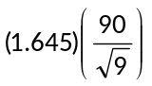= 49.35 minutes
n = 25 | 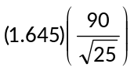= 29.61 minutes
n = 81 | 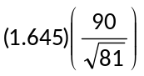 = 16.45 minutes

From 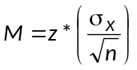, we see that the margin of error is inversely proportional to the sample size.
- If you want to cut the margin of error in half, you must increase the sample size by a factor of 4.
- If you want to reduce the margin of error by a factor or 3, you must increase the sample size by a factor of 9.

Suppose that we wanted to determine the minimum sample size required to estimate the true mean lifetime of all the batteries to within a specified margin of error M with a C% level of confidence. Thus, we want to find n so that
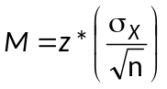.
Multiply both sides of the equation by 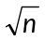.  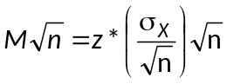
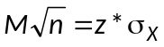
Divide both sides of the equation by M.  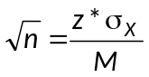
Finally, solve for n by squaring both sides of the equation.  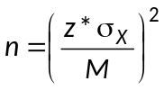
Use the equation to find the sample size needed to estimate the population mean to within a specified margin of error M with a confidence level of C%. This formula will rarely yield a whole number. Since a sample size must be a whole number, always round your answer up to the nearest whole number so that the margin of error is less strictly than M.
8.4 A z-Confidence Interval for a Population Mean: σ known or assumed
Example 7: A Sample Size Calculation
Refer to our population of 10,000 batteries. Find the minimum sample size needed to estimate the true mean lifetime to within 15 minutes of actual value with a 95% level of confidence.
Solution
We will use the formula where σ_{X} = 90 minutes, M = 15 minutes,
and z* = 1.960 (the critical value of a 95% confidence interval).
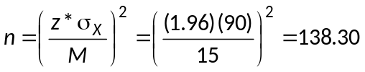.
As expected, the result is not a whole number. Round this number up to 139 batteries.
Answer: A minimum sample of size 139 batteries is needed to estimate the true mean lifetime to within 15 minutes of the actual value with a confidence level of 95%.

8.5 The Student’s t-distribution
Example 8
Suppose we want to estimate the true mean systolic blood pressure of all long-haul truck drivers at a large trucking company. From a random sample of 41 long-haul truck drivers, the mean systolic blood pressure is 130 mm Hg with a standard deviation of s_{X} = 12 mm Hg.
- Define the parameter.

- Estimate the parameter with a point estimate

- If the population standard deviation were known, what would be the approximate sampling distribution of the sample mean?

- What is the distribution of 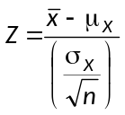?

- In this study, the population standard deviation is not known and must be approximated by the sample standard deviation. Use this value to approximate the standard deviation of the sampling distribution.

- IMPORTANT QUESTION
If we replace σ_{X} with s_{X}, do you think that 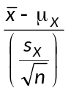 still has a standard normal distribution?

8.5 The Student’s t-distribution
When the population standard deviation is unknown (and hence, estimated from the sample data), we use the statistic s_{X} to estimate the parameter σ_{X}. As a result of this additional source of variation, the statistic 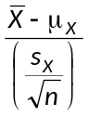 no longer has a normal distribution. Instead, under certain conditions, this statistics has a Student’s t-distribution. Several notes about the history and properties of the Student’s t-distribution are worthy of mention.
Properties of the Student’s t-Distribution
- W. S. Gosset published the Student’s t-distribution in 1908. Gosset was a Guinness brewery employee and published his work under the pseudonym “Student”.  - In his publications, Gosset assumed that random samples were taken from a normal population. As the sample size increases, the normality assumption becomes less important. | 
- Like the standard normal distribution, the t-distribution is symmetric about its mean of 0.
- Unlike the standard normal distribution, the t-distribution has a standard deviation greater than 1. This is due to the additional variation from the use of s_{X}. However, as the sample size increases, the standard deviation gets closer and closer to 1. Also, as the sample size increases, the normality assumption becomes less and less important and the distribution of gets closer and closer to that of a standard normal distribution.
- The t-distribution is less peaked at the mean and thicker at the tails that the standard normal distribution.
- The t-distribution has a separate shape for each sample size, which is in turn characterized by degrees of freedom. (You will learn the exact relation between the sample size and degrees of freedom later in the chapter.) As the degrees of freedom increase, the shape of the t-distribution gets closer and closer to that of the standard normal distribution.
- The figure below compares the density function for the t-distribution with 3 degrees of freedom, the t-distribution with 9 degrees and the standard normal distribution.
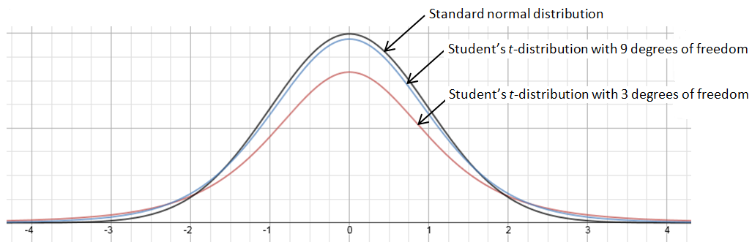
8.6 A t-Confidence Interval for a Population Mean:  unknown
A t-Confidence Interval for a Population Mean: σ is unknown
When the conditions are met and the population standard deviation is unknown (and hence, estimated from the sample data), a C% confidence interval for the unknown mean μ is 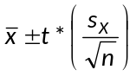 where t* is the critical value for the Student’s t-distribution with n – 1 degrees of freedom with C% of the area between –t* and t*.
- Since 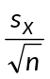 is now an estimate of the standard deviation of the sampling distribution, we define this quantity as the standard error of the mean.
- As before, we define 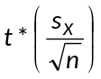 to be the margin of error of the estimation.
The conditions for this inference procedure are
- A random sample has been selected from the population.
- The 10% condition: Check that N > 10n.
- The population has an approximate normal distribution OR the sample size is large ( n > 30 ).
Example 9
A table or calculator will be used to obtain the critical values for a Student’s t-distribution. Remember that for a confidence interval for a population mean, the degrees of freedom is one less than the sample size ( df = n – 1 ).
- Find the critical value for a 95% confidence interval using a sample of size n = 5.
df = ________ t* = _____________
- Find the critical value for a 99% confidence interval using a sample of size n = 10.
df = ________ t* = _____________
alpha-value   | α = 0.100  (CL = 80%) | α = 0.050  (CL = 90%) | α = 0.025  (CL = 95%) | α = 0.010  (CL = 98%) | α = 0.005  (CL = 99%)
df
1 | 3.078 | 6.314 | 12.706 | 31.821 | 63.656
2 | 1.886 | 2.920 | 4.303 | 6.965 | 9.925
3 | 1.638 | 2.353 | 3.182 | 4.541 | 5.841
4 | 1.533 | 2.132 | 2.776 | 3.747 | 4.604
5 | 1.476 | 2.015 | 2.571 | 3.365 | 4.032
6 | 1.440 | 1.943 | 2.447 | 3.143 | 3.707
7 | 1.415 | 1.895 | 2.365 | 2.998 | 3.499
8 | 1.397 | 1.860 | 2.306 | 2.896 | 3.355
9 | 1.383 | 1.833 | 2.262 | 2.821 | 3.250
10 | 1.372 | 1.812 | 2.228 | 2.764 | 3.169

8.6 A t-Confidence Interval for a Population Mean: σ unknown
Example 10
Suppose we want to estimate the true mean systolic blood pressure of all long-haul truck drivers at a large trucking company with a 95% confidence interval. From a simple random sample of 41 long-haul truck drivers, the mean systolic blood pressure is 130 mm Hg with a standard deviation of s = 12 mm Hg. Construct and interpret the 95% confidence interval. Show all four steps.
Solution
Choose the correct inference procedure.
We will calculate a 95% confidence interval for a population mean with an unknown σ. The standard deviation will be estimated from the sample data.
Check the conditions
- A simple random sample was selected. ✓
- 10% condition: We will assume there are more than 410 truckers working for the company. ✓
- We don’t know whether the population distribution of systolic blood pressures is normal. Because the sample size is large (n = 41 > 30), we should be safe using a t-distribution.
Carry out the inference procedure
To find the critical value t*, we use a t-distribution with df = 41 – 1 = 40.
For a 95% level of confidence, t* = 2.021.
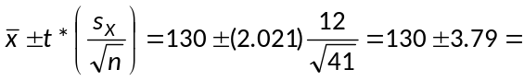(126.21, 133.79).
State the conclusion by interpreting the confidence interval
We are 95% confident that the true mean systolic blood pressure of all long-haul truckers at the company is between 126.2 mm Hg and 133.8 mm Hg.
Example 11
In the calculation of the confidence interval in example 10, identify the value of each of the following.
- The point estimate of the parameter. _______________
- The critical value. _______________
- The (estimated) standard deviation* of the point estimate. _______________
- The margin of error. _______________

*An estimated standard deviation is called a standard error.
8.6 A t-Confidence Interval for a Population Mean: σ unknown
Determining a Sample Size
Suppose we want to find the minimum sample size required to estimate the true mean systolic blood pressure to within 2.5 mm Hg? We could use the same procedure as in exercise 4: set the margin of error equal to 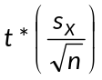 and solve for n. This time, the sample size would be in terms of the sample standard deviation s_{X} (which is not a problem). But there is a “Catch 22” (https://www.youtube.com/watch?v=5yeGMaT3PvI). The formula would also require knowing the value of t*. However, finding the value of t* requires knowledge of the sample size n (so as to determine the degrees of freedom).
To get around this circular problem, we simply use the value of z* in place of t*. Since our goal is to obtain only a ballpark estimate of the minimum sample size, the use of this approximation is acceptable. Thus, we will use the formula
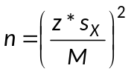
to approximate the minimum sample size necessary to estimate the sample mean to within a given margin of error M. Notice that the formula also presupposes knowledge of an approximate value for the population standard deviation.
Finally, you are reminded that when using the above formula, always remember to round the sample size up to the nearest whole number so that the margin of error is less strictly than M.
Example 12: A Sample Size Calculation
Suppose we want to find the minimum sample size required to estimate the true mean systolic blood pressure to within 2.5 mm Hg with a 95% level of confidence. Use the sample standard deviation of 12 mm Hg.
Solution
We will use the formula where s_{X} = 12 mm Hg, M = 2.5 mm Hg,
and z* = 1.960 (the critical value of a 95% confidence interval).
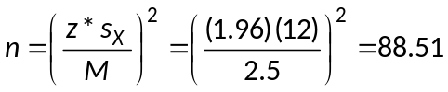.
As expected, the result is not a whole number. Round this number up to 89 long-haul truckers.
Answer
A minimum sample of size 89 long-haul truckers is needed to estimate the true mean systolic blood pressure to 2.5 mm Hg of the actual value with a confidence level of 95%.

8.6 A t-Confidence Interval for a Population Mean: The Matched-Pairs Design
Example 13
Trace metals found in wells affect the taste of drinking water, and high concentrations can pose a health risk. Researchers measured the concentration of zinc (in mg/liter) near the top and the bottom of 10 randomly selected wells in a large region. The data are provided in the table below.
Well | 1 | 2 | 3 | 4 | 5 | 6 | 7 | 8 | 9 | 10
Bottom | 0.430 | 0.266 | 0.567 | 0.531 | 0.707 | 0.716 | 0.651 | 0.581 | 0.469 | 0.723
Top | 0.415 | 0.238 | 0.390 | 0.410 | 0.605 | 0.609 | 0.632 | 0.523 | 0.411 | 0.611
Difference | 0.015 | 0.028 | 0.177 | 0.121 | 0.102 | 0.107 | 0.019 | 0.058 | 0.058 | 0.112
- Construct and interpret a 95% confidence interval for the mean difference μ in the zinc concentrations from these two locations.
Answer
We are 95% confident that the true mean difference in the zinc concentration (bottom – top) is between 0.041 mg/liter and 0.120 mg/liter.

- Does your interval in part (a) give convincing evidence of a difference in zinc concentrations at the top and bottom of the wells in the region? Justify your answer.
8.7 A z-Confidence Interval for a Population Proportion
This section presents a procedure for constructing a confidence interval for a population proportion p.
Recall the following important results from chapter 7….
- The sample proportion is an unbiased estimate of the population proportion p.
- The sampling distribution of the sample proportion is approximately normal with mean and standard deviation as long as the population size is at least ten times the size of the random sample ( N > 10n ) and both n⋅p > 10 and n⋅(1 – p) > 10.
Also, recall that the general form for a confidence interval is
Point Estimate ± Margin of Error
Point Estimate ± (Critical Value)⋅(Standard Deviation of the Statistic)
Clearly, the confidence interval for a population proportion p requires (1) a point estimate of p () , (2) the appropriate critical value (z*), and (3) the standard error of , . Unfortunately, we have another “Catch 22.” The computation of 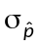 requires knowledge of p. In the absence of a known or assumed value for p, we estimate p with the point estimate . We denote the estimate of 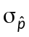 is denoted by 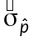. Thus,
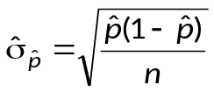.
The estimate is known as the standard error of .
Definition: Standard Error
When the standard deviation of a statistic is estimated from data, the result is called the standard error of the statistic.
- Since estimates the value of, we call the standard error of the sample mean.
- Since 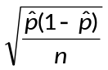estimates the value of , we call the standard error of the sample proportion.
8.7 A z-Confidence Interval for a Population Proportion
A z-Confidence Interval for a Population Proportion
When the conditions are met, a C% confidence interval for the unknown proportion p is
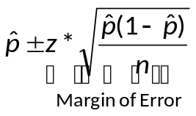
where z* is the critical value for the z-distribution, with C% of the area between –z* and z*.
- We call the quantity 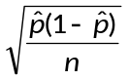 the standard error of the sample proportion.
- We call the quantity 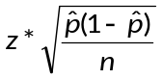 the margin of error of the estimation.
The conditions for this inference procedure are:
- A random sample has been selected from the population.
- The 10% condition: Check that N > 10n.
- The large counts condition: The values of n and must satisfy both n⋅ > 10 and n⋅(1 –) > 10.
Example 14
From a random sample of 1411 youths from across the state of Pennsylvania, researchers found the 219 youths were obese. The point estimate for the proportion of all PA youths that are obese is . Construct and interpret a 99% confidence interval for the true proportion of obese youths in Pennsylvania.
Solution
Choose the correct inference procedure.
We will calculate a 99% confidence interval for a population proportion.
Check the conditions
- A simple random sample was selected. ✓
- 10% condition: It is safe to assume that there are more than 14,111 youths in PA. ✓
- The large counts condition: n = 1411(0.155) = 219 > 10 ✓ n(1 –) = 1411(0.845) = 1192 > 10 ✓
Carry out the inference procedure
For a 99% level of confidence, z* = 2.576.
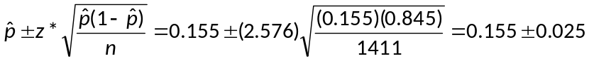= (0.130, 0.180).
State the conclusion by interpreting the confidence interval
We are 99% confident that the true proportion of obese youths in Pennsylvania is between 0.130 and 0.180.
8.7 A z-Confidence Interval for a Population Proportion
Example 15
In the calculation of the confidence interval in example 14, identify the value of each of the following.
- The point estimate of the population proportion _______________
- The critical value _______________
- The standard error of the point estimate _______________
- The margin of error _______________

Determining a Sample Size
We now wish to determine the minimum sample size needed to estimate a population proportion to within a given margin of error M and a specified level of confidence. As we did with the confidence interval for the population mean, set the expression for the margin of error equal to M.
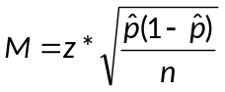.
Multiply both sides of the equation by .  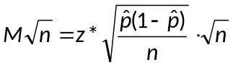
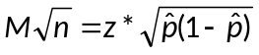

Divide both sides of the equation by M.  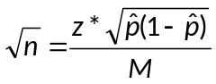
Finally, solve for n by squaring both sides of the equation.  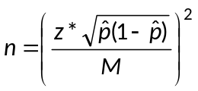
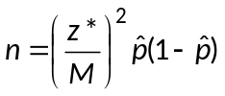
This final version of the formula will be used if a “ballpark” estimate of p is known. If the value of p is completely unknown, it can be shown (using Calculus methods) that the standard error for is a maximum when = 0.50.
As before, this formula will rarely yield a whole number. Since a sample size must be a whole number, always round your answer up to the nearest whole number so that the margin of error is less strictly than M.

8.7 A z-Confidence Interval for a Population Proportion
Example 17: A Sample Size Exercise
Return to example 15. Determine the minimum sample size needed to estimate the true proportion of obese youths to within 1.5% with a 99% level of confidence. Use the estimate for p from example 15.
Solution
We will use the formula where = 0.155, M = 0.015,
and z* = 2.576 (the critical value for a 99% confidence interval).
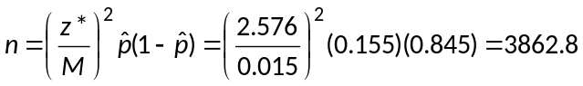.
As expected, the result is not a whole number. Round this number up to 3863 youths.
Answer: A minimum sample of size 3863 youths is needed to estimate the true proportion of obese youths in Pennsylvania with a confidence level of 99%.

 | Example 18: A Sample Size Exercise  How many M&Ms must be sampled to estimate the true proportion of red M&Ms to within 2% of the actual value with a 95% level of confidence?
Solution
We will use the formula where M = 0.02 and z* = 1.960.
In the absence of a preliminary estimate of , we will use 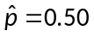. This is the value of that maximizes the standard error of the sample proportion.
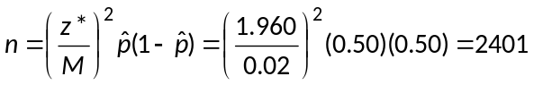.
In a rare occurrence, the answer is a whole number. I will still “bump up” the answer to the next whole number so that the margin of error is truly within 0.02.

Answer
A minimum sample of size 2402 M&Ms is needed to estimate the true proportion of red M&Ms to within 0.02 of the actual proportion.

8.8 Using the Graphing Calculator
Revisit Example 3: Find a z-confidence interval for a mean using data
Refer to our production run of 10,000 batteries. We want to estimate the true mean lifetime of all 10,000 batteries from a sample of size n = 9 obtained using line 101 of the random number table.
Battery # | 1922 | 3950 | 3405 | 7562 | 8713 | 9640 | 9125 | 3142 | 5448
Lifetime (min) | 1017 | 973 | 1102 | 979 | 935 | 1032 | 1036 | 978 | 1082
The sample mean lifetime is 1014.89 min. We will use the population standard deviation of  = 90 minutes to construct a 90% confidence interval for the true mean lifetime of all 10,000 batteries.
Step 1  Press [STAT].  From the EDIT menu, select 1: Edit.  Then [Enter]. | 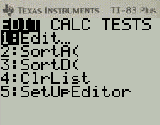
Step 2  Enter the data. | 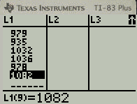
Step 3  Press [STAT].  From the TESTS menu, select 7: ZInterval.  Then [Enter]. | 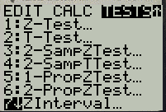
Step 4  Select the settings you see to the right. →  The interval will be calculated from Data (as opposed to summary Stats).  Indicate the population standard deviation of σ = 90.  The data is stored in list L₁.  The confidence level (C-level) is 0.9.  Finally, highlight Calculate, then [Enter]. | 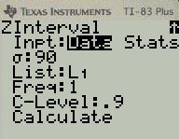
Result  This is what you will see. → | 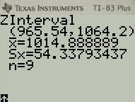
8.8 Using the Graphing Calculator
Revisit Example 10: Find a t-confidence interval for a mean using summary statistics
Suppose we want to estimate the true mean systolic blood pressure of all long-haul truck drivers at a large trucking company with a 95% confidence interval. From a simple random sample of 41 long-haul truck drivers, the mean systolic blood pressure is 130 mm Hg with a standard deviation of s = 12 mm Hg. Construct and interpret the 95% confidence interval. Show all four steps.

Step 1  Press [STAT].  From the TESTS menu, select 8: TInterval.  Then [Enter]. | 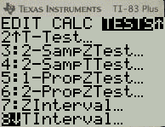
Step 2  Select the settings you see to the right. →  The interval will be calculated from summary Stats.  Enter the values of , s_{x}, n, and the confidence level C.  Finally, highlight Calculate, then [Enter]. | 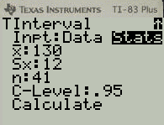
Result  This is what you will see. → | 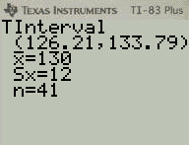

8.8 Using the Graphing Calculator
Revisit Example 13: Find a t-confidence interval for a mean, a matched-pairs design using data
Trace metals found in wells affect the taste of drinking water, and high concentrations can pose a health risk. Researchers measured the concentration of zinc (in mg/liter) near the top and the bottom of 10 randomly selected wells in a large region. The data are provided in the table below. Construct and interpret a 95% confidence interval for the mean difference m in the zinc concentrations from these two locations.
Well | 1 | 2 | 3 | 4 | 5 | 6 | 7 | 8 | 9 | 10
Bottom | 0.430 | 0.266 | 0.567 | 0.531 | 0.707 | 0.716 | 0.651 | 0.581 | 0.469 | 0.723
Top | 0.415 | 0.238 | 0.390 | 0.410 | 0.605 | 0.609 | 0.632 | 0.523 | 0.411 | 0.611

Step 1  Press [STAT].  Enter the two sets of data in L₁ and L₂.  Press [2nd] [MODE] to quit.  Calculate the differences by entering L₁–L₂.  Press [STO] [2nd] [3] to save the difference data in list L₃. | 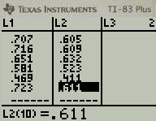 | 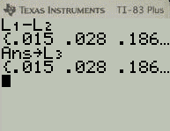
Step 2  To view the difference data, press [STAT].  From the EDIT menu, select 1: Edit.  You should see the difference data in list L₃. |  | 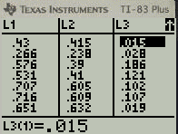
Step 3  Press [STAT].  From the TESTS menu, select 8: TInterval.  Then [Enter]. |  | 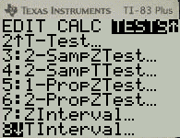
Step 4  Select the settings you see in the left screen. →  The interval will be calculated from Data.  The data is found in List L₃.  The confidence level (C-level) is 0.95.  Finally, highlight Calculate, then [Enter].  You will see the information in the right screen. → | 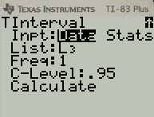 | 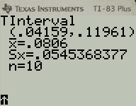

8.8 Using the Graphing Calculator
Revisit Example 14: Find a z-confidence interval for a proportion using counts
From a random sample of 1411 youths from across the state of Pennsylvania, researchers found the 219 youths were obese. The point estimate for the proportion of all PA youths that are obese is . Construct and interpret a 99% confidence interval for the true proportion of obese youths in Pennsylvania.
Step 1  Press [STAT].  From the TESTS menu, select A: 1-PropZInt.  Then [Enter]. | 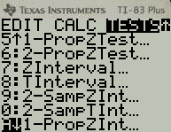
Step 2  Select the settings you see to the right. →  Enter the values of x (the number of successes), n (the sample size),  and the confidence level C.  Finally, highlight Calculate, then [Enter]. | 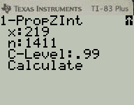
Result  This is what you will see. → | 